**General Notes about React JS**

* We can use ‘*npm start*’ to restart the react project. If react app has built using create-react-app
* The DOM is a standardized way to represent and manipulate the structure, content, and style of web documents. It serves as a bridge between web pages and programming languages, allowing developers to create dynamic and interactive web applications.  
    
  ReactJs uses Virtual DOM. A virtual DOM is nothing but a JavaScript Object. It is a light weight representation of real DOM.  
  Updating the virtual DOM is much faster than updating the Real DOM because we don’t have to worry about the Javascript DOM api. Thus, react only update the section of the page where the change was made not the entire page which is super efficient.  
  When something changes in a component we get a new react element. React will then compare this element and the children of that element with the previous DOM and it figures out what has changed and then it will update a part of the real DOM to keep it in sync with the virtual DOM.
* React Js is a component-based front-end Javascript Library.  
  Which means that all parts of our web applications are divided into small components.   
  A components is a small piece of the user interface. Every react.js application is a tree of components.  
  Components let you split the ui into independent reusable parts then we combine then to build a full-fledged web application.  
  In React there are two types of components:-  
  **1. Functional** components:  
  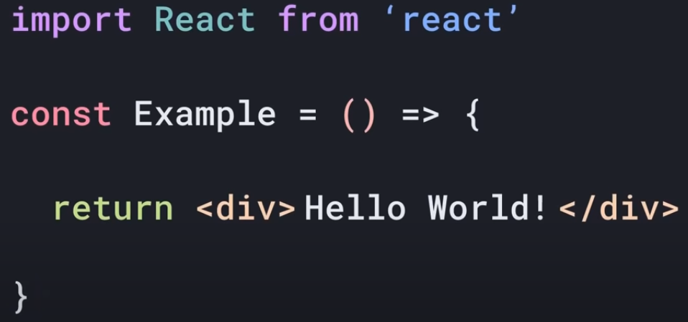  
    
  **2. Class-based** components:  
  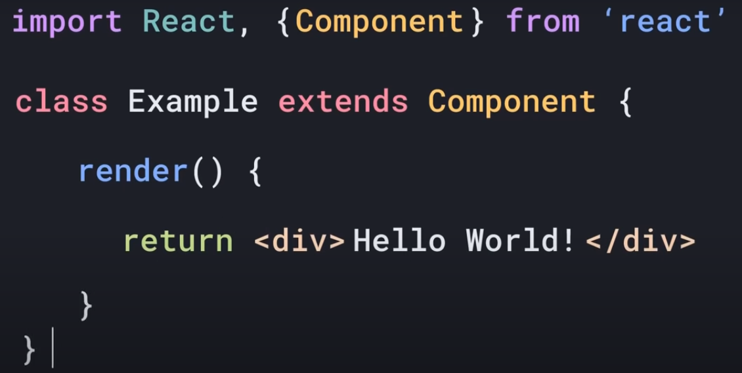  
    
  Statement written inside return called “JSX”.  
  JSX is used in React to descript what the User Interface should look like.
* There are 2 ways to setup React Environment:  
  1. Manually setting up all the things using webpack and babel.  
  2. Using the create-react-app command. (By npm).
* In Order to use any JavaScript method, loop, variables or keyword inside react component, we’ve to write it inside curly Braces{}.
* To use map() method with any array, in order to render a single component multiple times. We may or may not use round braces () but can’t use {} braces, with the arrow function that passes it as parameter with map().
* In react we may or may not use round () braces with any specific function or return keyword.  
  But if we’re not keeping the code inside () braces with return keyword then we must have to start that code with the same line with the return keyword.
* In React state management is not same as we does in html/vanilla-Js. That’s why here we use “useState” & “useEffect” by importing it from react module.  
    
  Since, both “useState” & “useEffect” are hook. So, in react hooks are always use inside the component and before the return keyword.  
  Syntax:   
  const [miPhoneToggle, setmiPhoneToggle] = useState(false);  
    
  We can’t use Link when using “useState” & “useEffect” instead we’ve to use anchor Tags.
* There is rule in react that never mutate or change state variable manually. It should mutate only using setter function.

**How to run locally hosted react app build using vite on mobile device?**

Ans:  
Firstly make sure both the device mobile and development system should connected to the same network.

1. Check the IPv4 address of your network by running the following command in cmd terminal:  
   **ipconfig**It might be under "Ethernet adapter Ethernet" or "Wireless LAN adapter Wi-Fi". The IP address typically starts with "192.168" or "10.0".  
   For Ex: 192.168.29.7
2. Add this server object in vite.config.js file:  
   server: {

host: '0.0.0.0',

}  
Under the default defineConfig object.  
It would look like this:  
export default defineConfig({

plugins: [react()],

server: {

host: '0.0.0.0',

},

})

1. Run the command: **npm run dev**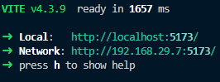

**DEPLOYMENT:-**

Netlify.com:

More More Info - [*https://docs.netlify.com/cli/get-started/*](https://docs.netlify.com/cli/get-started/)

Steps-1:  
Make sure you’ve installed netlify cli using this command:  
*npm install netlify-cli –g*To Check: type netlify in the terminal

Step-2:  
netlify login (If not already login)

Step-3:  
Create build folder of your react project using this command:  
*npm run build*

Step-4:  
Run *netlify deploy*Make sure publish directory should be: *./build* or *./dist (in case of vite)*It will publish at draft URL

Step-5:  
run *netlify deploy –prod*  
For Full deployment as per required URL